**Angular Exercise:**

**Question:**

1. **Component and Routing – Create View Employee Component**  
  
Earlier employee details were created in the default app component itself.

* This now has to be moved to a new component named "view-emp". Follow the steps below:
* Create a new component in angular-learning application created earlier with component name "view-emp".
* Copy and paste relevant code from html and component source from app component to this new component.
* Create another component "edit-emp" to have a placeholder for another component that will be developed later. This is primarily to check how router navigation works.
* Include routing with router link “View Employee” and "Edit Employee" pointing to this new component. Clicking either one of the link should display the respective component. Refer sample layout below.

**Code:**

App.component.html:

<div class="container">

    <div class="row"></div>

    <div class="col-xs-12 col-sm-10 col-md-8 col-sm-offset-1 col-md-offset-2">

      <ul class="nav nav-tabs">

        <li role="presentation" routerLinkActive="active" [routerLinkActiveOptions]="{exact:true}"><a routerLink="/">View Employee</a></li>

        <li role="presentation" routerLinkActive="active"><a routerLink="/edit">Edit Employee</a></li>

      </ul>

    </div>

</div>

<div class="row">

    <div class="col-xs-12 col-sm-10 col-md-8 col-sm-offset-1 col-md-offset-2">

      <router-outlet></router-outlet>

    </div>

</div>

App-routing.component.ts:

import { NgModule } from '@angular/core';

import { Routes, RouterModule } from '@angular/router';

import { EditemployeeComponent } from './editemployee/editemployee.component';

import { EmployeeComponent } from './employee/employee.component';

import { PagenotfoundComponent } from './pagenotfound/pagenotfound.component';

const routes: Routes = [

  {path:'', component:EmployeeComponent},

  {path:'edit', component:EditemployeeComponent},

  {path:'not-found',component:PagenotfoundComponent},

  {path:'**',redirectTo:'/not-found'}

];

@NgModule({

  imports: [RouterModule.forRoot(routes)],

  exports: [RouterModule]

})

export class AppRoutingModule { }

Employee.component.html:

<div>

<h1> Employee details</h1>

<div class="well hoverwell thumbnail">

    <h2>Employee Id: {{emp.id}}</h2>

    <h2>Employee Name: {{emp.name}}</h2>

    <h2>Salary: {{emp.salary | currency:"INR"}}</h2>

    <h2 *ngIf="show">Permanent: Yes </h2>

    <h2>Department Id: {{emp.depart.department_id}}</h2>

    <h2>Department Name: {{emp.depart.department_name}}</h2>

    <h2>Skills</h2>

    <table >

        <tr>

            <th>Skill Id</th>

            <th>Skill Name</th>

     </tr>

     <tr *ngFor="let emp of empl">

        <td>{{emp.skill.skill_id}}</td>

        <td>{{emp.skill.skill_name}}</td>

    </tr>

        </table>

     <h2>Date Of Birth: {{emp.dateOfBirth | date:'longDate'}}</h2>

</div>

</div>

EditEmployee.component.html:

<p>Edit Employee works!</p>

**Output:**

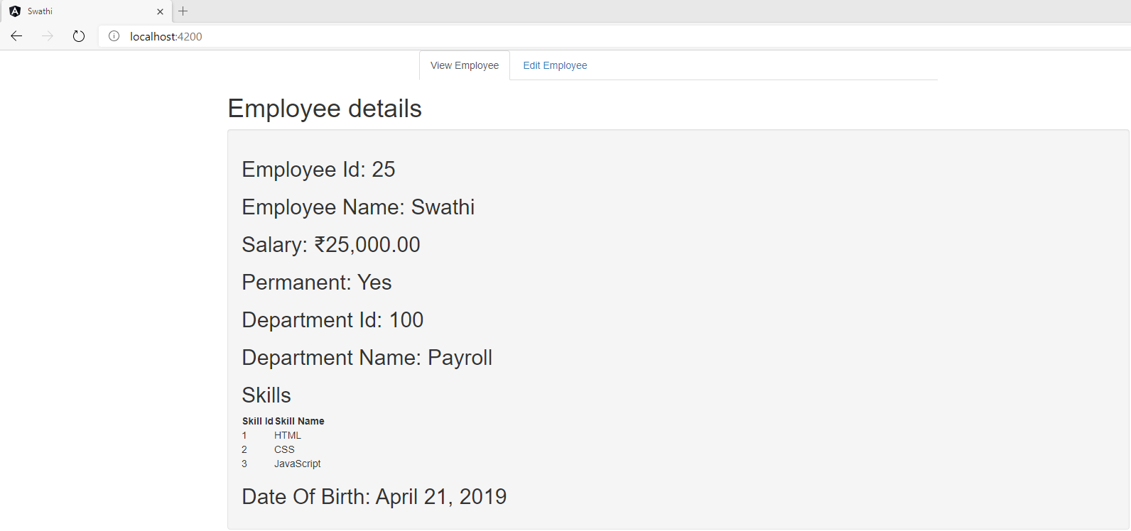

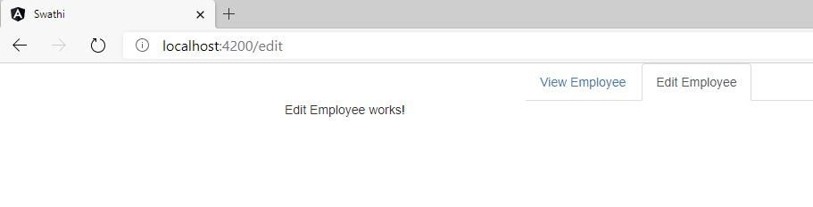

**Question:**

2.**Event Handling - Display value based on button click**  
  
In online food ordering apps, to add a specific food item with multiple quantity, there will be a plus and minus button that helps in increasing or decreasing the number of items. We are gradually going to build a component that will achieve this functionality.  
  
As part of this particular exercise we will create a button named "Click me". Clicking on this button should display the message "Click me button clicked!"  
  
Create a new component named "quantity-increment".

**Code:**

App.component.html:

<div class="container">

    <div class="row"></div>

    <div class="col-xs-12 col-sm-10 col-md-8 col-sm-offset-1 col-md-offset-2">

      <ul class="nav nav-tabs">

        <li role="presentation" routerLinkActive="active" [routerLinkActiveOptions]="{exact:true}"><a routerLink="/">View Employee</a></li>

        <li role="presentation" routerLinkActive="active"><a routerLink="/edit">Edit Employee</a></li>

        <li role="presentation" routerLinkActive="active"><a routerLink="/quantity">Quantity Increment</a></li>

      </ul>

    </div>

</div>

<div class="row">

    <div class="col-xs-12 col-sm-10 col-md-8 col-sm-offset-1 col-md-offset-2">

      <router-outlet></router-outlet>

    </div>

</div>

App-routing.module.ts;

import { NgModule } from '@angular/core';

import { Routes, RouterModule } from '@angular/router';

import { EditemployeeComponent } from './editemployee/editemployee.component';

import { EmployeeComponent } from './employee/employee.component';

import { PagenotfoundComponent } from './pagenotfound/pagenotfound.component';

import { QuantityIncrementComponent } from './quantity-increment/quantity-increment.component';

const routes: Routes = [

  {path:'', component:EmployeeComponent},

  {path:'edit', component:EditemployeeComponent},

  {path:'quantity', component:QuantityIncrementComponent},

  {path:'not-found',component:PagenotfoundComponent},

  {path:'**',redirectTo:'/not-found'}

];

@NgModule({

  imports: [RouterModule.forRoot(routes)],

  exports: [RouterModule]

})

export class AppRoutingModule { }

Quantity-increment.component.ts:

import { Component, OnInit } from '@angular/core';

@Component({

  selector: 'app-quantity-increment',

  template: `

  <button (click)="onClickMe()">Click me!</button>

  {{clickMessage}}`

})

export class QuantityIncrementComponent implements OnInit {

  constructor() { }

  ngOnInit(): void {

  }

  clickMessage = '';

  onClickMe() {

    this.clickMessage = 'Click Me Button Clicked!';

  }

}

**Output:**

**Layout before button click:**

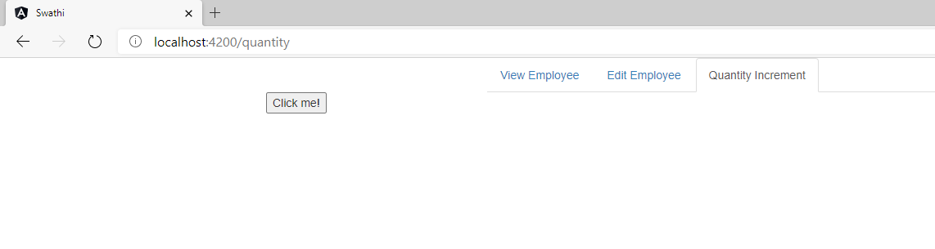

**Layout after button click:**

